- HOW TO USE A.T.R.T
- HISTORY

How to use A.T.R.T

- A.T.R.T 2.1.0.1001 now support:
- XP SP2/SP3 (32/64 bit)
- Windows 2003 (32/64 bit)
- Vista SP1/SP2 (32/64 bit)
- Win7 SP0/SP1 (32/64 bit)
- Win8 (32/64 bit)

- A.T.R.T 2.1.0.1001 now can detect and clean bootkits and infection-rootkits as follows:

Virus Name | Virus Type | Verify with Sample | Comments
Rootkit.Boot.Phanta.b | Bootkit | Y
Rootkit.Win32.TDSS.tdl4 | Bootkit | Y
Rootkit.Boot.Cidox.a | Bootkit | Y
Rootkit.Boot.Xpaj.a | Bootkit | Y
Rootkit.Boot.Yurn.a | Bootkit | Y
Rootkit.Boot.Geth.a | Bootkit | Y
Rootkit.Boot.CPD.b | Bootkit | Y
Rootkit.Boot.SST.a | Bootkit | Y
Rootkit.Boot.Wistler.a | Bootkit | N | Have no sample
Rootkit.Boot.Sinowal.a | Bootkit | N | Have no sample
Rootkit.Boot.Nimnul.a | Bootkit | N | Have no sample
Rootkit.Boot.Trup.b | Bootkit | N | Have no sample
Rootkit.Boot.Backboot.a | Bootkit | N | Have no sample
Rootkit.Boot.Phanta.a | Bootkit | N | Have no sample
Rootkit.Boot.Phanta.c | Bootkit | N | Have no sample
Rootkit.Boot.Stoned.a | Bootkit | N | Have no sample
Rootkit.Boot.SST.b | Bootkit | N | Have no sample
Rootkit.Boot.Sinowal.b | Bootkit | N | Have no sample
Rootkit.Boot.Pihar.a | Bootkit | N | Have no sample
Rootkit.Boot.Pihar.b | Bootkit | N | Have no sample
Rootkit.Boot.Cidox.b | Bootkit | N | Have no sample
Trojan-Ransom.Boot.Mbro.d | Bootkit | Y
Rootkit.Boot.CPD.a | Bootkit | N | Have no sample
Rootkit.Boot.Plite.a | Bootkit | N | Have no sample
Rootkit.Boot.Qvod.a | Bootkit | N | Have no sample
Rootkit.Boot.Smitnyl.a | Bootkit | N | Have no sample
Rootkit.Boot.Harbinger.a | Bootkit | N | Have no sample
Rootkit.Win32.TDSS.tdl3 | Infection-Rootkit | Y | Test on some variants
Virus. Win32.ZAccess | Infection-Rootkit | Y | Test on some variants

Additionally, A.T.R.T 2.1.0.1001 can scan and clean suspicious boot sectors and files, but we recommend you just skip the suspicious item and upload related results for further analysis.

- Run ATRT.exe as administrator if under Vista/Win7/Win8
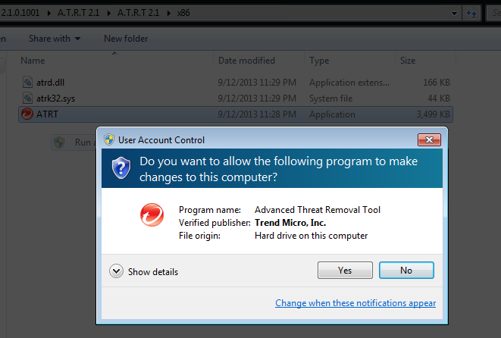

- Click Start to scan
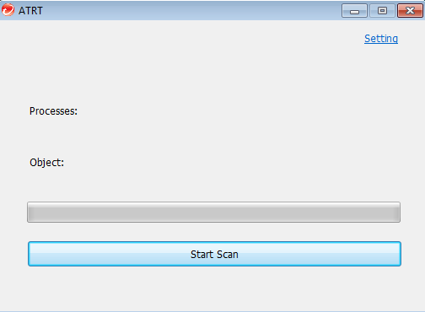

- Optionally, click Setting
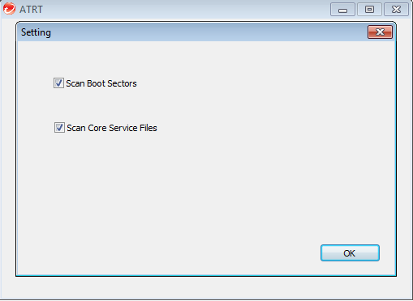
Scan boot sectors(MBR/VBR/IPL) or core service files as you want.

- Choose ‘clean’ or ‘skip’ when virus/suspicious bin is found
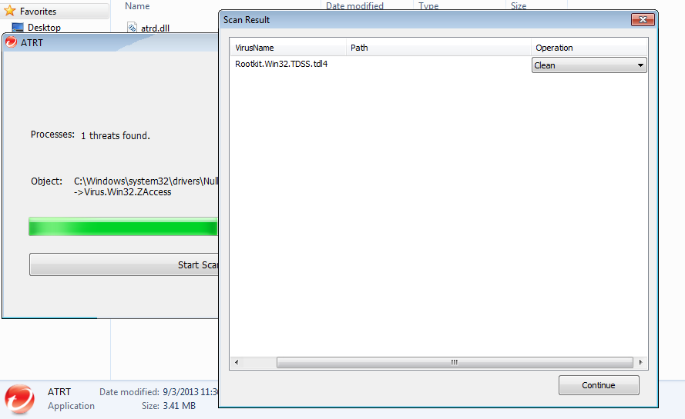

- Restart computer if needed
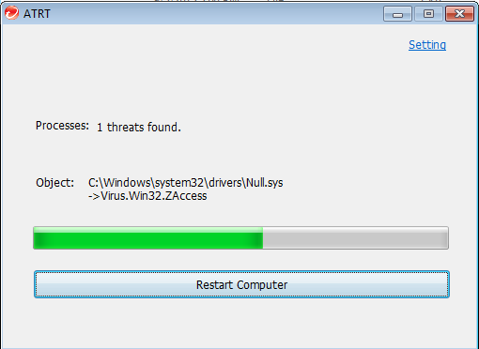

- After clean, A.T.R.T will provide a report and dump virus binary with encryption for further analysis.
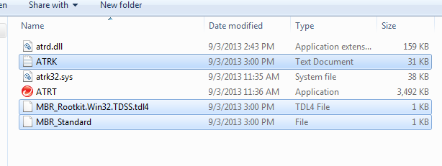

History

- A.T.R.T 2.1.0 1001
atrd.dll [1.3.0.1003]
atrk32/atrk64.sys [1.1.0.1003]
atrt.exe [1.2.0.1003]

add support for x64

- A.T.R.T 2.0.0.1000

atrd.dll [1.2.0.1002]
atrk32.sys [1.0.0.1002]
atrt.exe [1.1.1.1002]

- fix bugs that some ZeroAccess variants under Win7 can terminate our process

- add one more signature for ZeroAccess

- A.T.R.T 1.1

atrd.dll [1.1.0.1001]
atrk32.sys [1.0.0.1001]
atrt.exe [1.1.0.1001]

- solve the FA:
On disk-encryption computer, ATRT will detect everything as suspicious.

- add some message
When suspicious one is detected, the binary is requested to be uploaded.

- A.T.R.T 1.0

atrd.dll [1.0.0.0]
atrk32.sys [1.0.0.0]
atrt.exe [1.0.0.0]

create

If any question, please feel free to contact me by e-mail( Juwei_lin@trendmicro.com.cn)

